You Cannot be Serious:

The Impact of Accuracy Incentives on Partisan Bias

in Reports of Economic Perceptions

Markus Prior, Princeton University

Gaurav Sood, Independent Researcher

Kabir Khanna, Princeton University

July 29, 2015

Abstract
When surveyed about economic conditions, supporters of the president’s party often report more positive conditions than its opponents. Scholars have interpreted this finding to mean that partisans cannot even agree on matters of fact. We test an alternative interpretation: Partisans give partisan congenial answers even when they have, or could have inferred, information less flattering to the party they identify with. To test this hypothesis, we administered two surveys to nationally representative samples, experimentally manipulating respondents’ motivation to be accurate via monetary incentives and on-screen appeals. Both treatments reduced partisan differences in reports of economic conditions significantly. Many partisans interpret factual questions about economic conditions as opinion questions, unless motivated to see them otherwise. Typical survey conditions thus reveal a mix of what partisans know about the economy, and what they would like to be true.

Word Count: 136
Keywords: partisanship, bias, economy, perceptions, political knowledge, accuracy incentives, motivated reasoning
According to the dominant scholarly view, partisanship pervades every aspect of how most Americans think and feel about politics. Starting with early work on voting behavior, none more influential than The American Voter (Campbell et al. 1960), and continuing at a steady pace (e.g., Lodge and Hamill 1986; Rahn 1993; Taber and Lodge 2006; Iyengar, Sood, and Lelkes 2012), documentation of partisanship as the structuring force in U.S. politics abounds. As perhaps the ultimate demonstration of this force, partisans even differ in their reports of objective conditions (see, especially, Bartels 2002).
In this paper, we push back against the view of partisanship as a ubiquitous, all-pervasive force. Specifically, we show that apparent disagreement on matters of fact between Republicans and Democrats does not always reflect deep-seated differences in beliefs produced by reality-defying partisanship. Instead, the disagreement is often {Bartels, 2002 #516;Bartels, 2002 #655;Jerit, 2012 #1244}induced by the operation of partisan motivation when people respond to factual questions. Partisans tend to treat factual questions as opinion questions. When we motivate them to answer factual questions accurately, we see that many partisans have the capacity to acknowledge inconvenient truths. To put it bluntly, this is bad news for survey research, but good news for democracy.
Whether or not partisan bias extends to perceptions of reality is an important question for democratic politics. Without agreement on some key facts, democratic decision-making becomes rather difficult. Democrats and Republicans are expected to disagree about the urgency of reducing the budget deficit. But if they even disagree about the size of the budget deficit, compromise on matters of policy seems more elusive still. Belief in incorrect facts can impair citizens’ application of political values to policy questions (Hochschild 2001, 321). People who are misinformed about relevant facts likely get their preferences “wrong” too: “When partisan disagreements about important factual issues show that large subsets of the public are necessarily wrong about the facts, then there is clearly cause for concern about the political preferences that people based on their views of the facts” (Shapiro and Bloch-Elkon 2008, 131). If people use economic conditions to judge the incumbent’s performance (e.g., Fiorina 1981), partisan biases in knowledge of economic conditions weaken such accountability. On the other hand, if partisanship only affects reports of perceptions, not perceptions themselves, estimates of perceptions’ influence on variables related to partisanship, such as vote choice or presidential approval, would be biased upwards (see, e.g., Enns, Kellstedt, and McAvoy 2012, 300).
In opinion surveys, partisans tend to differ in their reports of objective conditions. In 1988, at the end of President Reagan’s second term, for example, the American National Election Study (ANES) asked respondents whether “compared to 1980, the level of unemployment in the country ha[d] gotten better, stayed about the same, or gotten worse?” Bartels (2002) shows that even though the unemployment rate had declined from 7.1 percent in 1980 to 5.5 percent in 1988, only about 30 percent of strong Democrats said that “the level of unemployment… ha[d] gotten better.” In contrast, over 80 percent of strong Republicans and nearly 70 percent of weak Republicans correctly reported that unemployment had declined. When the ANES in 1996 asked about changes during President Clinton’s first term, more Republicans than Democrats failed to acknowledge positive changes in some economic indicators. Compared to 39 percent of Democrats, only 25 percent of Republicans reported that the budget deficit “ha[d] decreased… during Clinton’s time as President”—despite a sharp decline, from $255 billion in fiscal year 1993 to $22 billion in fiscal year 1997 (Achen and Bartels 2006). Partisan differences in reports of objective conditions are not limited to the economy. Across domains, opponents of the president’s party tend to report poorer conditions than supporters of the president’s party (Bartels 2002; Jerit and Barabas 2012; Ansolabehere, Meredith, and Snowberg 2013; see also Kuklinski et al. 2000).
There are reasons to believe that partisan differences in reports of objective conditions reflect deep-seated beliefs. People tend to more readily accept information that is congenial to their partisan affiliation (e.g., Lodge and Taber 2000; Redlawsk 2002). The American Voter (Campbell et al. 1960, 133) called this a “perceptual screen through which the individual tends to see what is favorable to his partisan orientation. The stronger the party bond, the more exaggerated the process of selection and perceptual distortion will be.” Reliance on partisan stereotypes (“schemas”), selective exposure and attention, and motivated processing of information may lead partisans to hold beliefs that are in line with their partisanship (Lodge and Hamill 1986; Zaller 1992; Rahn 1993; Taber and Lodge 2006).
But a second explanation is also conceivable: Partisans give answers that reflect well on their party even when they have information that is less flattering to their party, or could have easily inferred such information. Even if partisan respondents hold accurate beliefs, their motivation to give an answer consistent with their partisan dispositions may outweigh their motivation to give an accurate response. Partisans who lack information may give a congenial answer based on on-the-spot partisan inferences that are convenient but biased, because they are not sufficiently motivated to use less biased inference rules that require greater effort.
In order to distinguish between the two explanations, we conducted two experiments that manipulated respondents’ incentives to answer factual questions accurately. In one treatment, we offered respondents bonus money for correct answers, and in another, we included an on-screen appeal encouraging respondents to answer correctly. Respondents in the control group answered questions in the traditional format, without any accuracy prompts. If partisan differences persist unabated despite incentives to respond correctly, these differences likely reflect deep-seated beliefs. If not, differences in partisans’ beliefs are likely smaller than what traditional surveys convey.
The hypothesis that monetary incentives reduce partisan bias in reported factual beliefs was first tested by Prior (2007). He analyzed the experimental data originally reported in Prior and Lupia (2008), which are also used in our Study 1. Instead of correctness of responses, the focus of Prior and Lupia (2008), Prior (2007) and our paper examine the effects of incentives on partisan bias. Our Study 2 constitutes a replication and extension of the original design. More recently, Bullock et al. (2015) also use monetary incentives to study partisan bias in reported beliefs. Their study yields findings that are broadly consistent with our own. We compare the two studies in greater detail in the conclusion.
Our main contribution is to show that, under typical survey conditions, answers to factual questions with partisan implications are contaminated by partisans’ motivation to give answers that reflect well on their party. Deliberately or not, some partisans treat factual questions with political relevance as an opportunity to root for their team. Deep-seated perceptual differences between partisans are substantially smaller than past work suggests. Scholars who want to measure beliefs must counteract these partisan consistency pressures by increasing partisans’ motivation to give accurate responses.
Theory and Hypotheses
The purpose of this study is to understand how people respond to factual survey questions with partisan relevance. People’s answers to such questions depend on 1) information they have stored in their memory, 2) the extent to which this information is accessible, which is partly a function of the effort people are willing to put into accessing it, 3) inferences they make during the response process, and 4) their motivation to accurately report accessible stored information and on-the-spot inferences.
Respondents’ memories may contain correct information, incorrect information, or no information at all (see Kuklinski et al. 2000). Many people in many political domains lack information (Bennett 1995; Delli Carpini and Keeter 1996). Incorrect information can result from unrepresentative personal experiences (Conover, Feldman, and Knight 1986; Ansolabehere, Meredith, and Snowberg 2011), a misreading of facts (Nyhan and Reifler 2010), exposure to sources that deliberately or inadvertently misrepresent facts (Bullock 2006), or faulty inferences based on other information (Kuklinski et al. 2000, 794-5). Selective exposure, selective attention, and motivated processing, all caused by prior beliefs or attachments, can also lead people to be uninformed or misinformed about conditions that do not favor their party (e.g., Lodge and Hamill 1986; Taber and Lodge 2006; Iyengar and Hahn 2009; Stroud 2011; Jerit and Barabas 2012).
For all these reasons, the information partisans hold in their memories may thus reflect well on their party. Many of the processes that lead to partisan differences in stored information reflect elements of motivated reasoning. Two kinds of motivations are particularly important: accuracy and consistency motivations (e.g., Festinger 1957; Kruglanski 1990; Kunda 1990; Chaiken, Giner-Sorolla, and Chen 1996). The accuracy goal motivates people to “arrive at an accurate conclusion, whatever it may be,” whereas the consistency goal motivates them to “arrive at a particular, directional conclusion” (Kunda 1990, 480). For consistency goals to operate in the political domain, respondents have to (consciously or subconsciously) treat the question as relevant to their political identity (see Jerit and Barabas 2012). Political scientists have used this theoretical perspective to explain partisan biases in attitude change and decision-making (e.g., Brady and Sniderman 1985; Lodge and Taber 2000; Redlawsk 2002; Taber and Lodge 2006; Nir 2011).
It is important to recognize, however, that motivations also operate during reporting of facts (and feelings, and attitudes). Memory searches and inference processes work differently when individuals are motivated to be accurate than when they are motivated to be consistent (e.g., Kunda 1990; Chaiken et al. 1996; Kruglanski 1996). Consistency goals are liable to lead respondents to terminate their memory search when it produces congenial information – that is, information that reflects well on their party. On the other hand, respondents motivated to be accurate are liable to search more evenhandedly, and continue searching even after accessing congenial information.
By the same token, consistency goals likely lead respondents who lack accessible information to rely on partisan cues to infer answers, whereas respondents motivated to be accurate may rely less on partisan inference (see Lodge and Taber 2000, 205-209). For example, a Democrat with low accuracy motivation who is asked to state the unemployment rate, but does not know it, may use a partisan inference rule because it is easy and often salient (Lodge and Hamill 1986; Rahn 1993). The rule leads her to infer that unemployment is high because Republicans control the White House. With greater accuracy motivation, on the other hand, she might recognize the fallibility of this inference rule and counteract it or use a different, less partisan rule. This process can even lead to overcorrections, such that accuracy motivation produces uncongenial inferences.
Once memory searches or inferences yield a result, motivations affect whether or not respondents report it faithfully. Respondents may want to give answers that they believe to be true (accuracy goal), but they may also want their answers to reflect well on their partisan dispositions (consistency goal). The accuracy goal motivates them to report accessible information faithfully. However, when accessible information clashes with their partisan dispositions, or other beliefs they hold, motivation to be consistent may interfere. It may lead respondents to knowingly give a consistent but incorrect response. Some partisans may give consistent answers they know to be wrong for expressive reasons, while others may do so for strategic reasons such as interest in influencing public opinion.
In all, partisans may report conditions they would like to see, not conditions they necessarily believe to be true. Because the information respondents hold in memory is unobservable, we translate this claim into the following testable hypothesis:
H1: Increasing accuracy motivation reduces partisans’ propensity to report congenial instead of uncongenial conditions.
If increasing accuracy motivation—which does not change the information available to respondents—reduces reports of congenial conditions, it follows that respondents either have inconsistent information in memory that they believe to be accurate but choose to reveal only when motivated to be accurate, or that sufficient motivation to be accurate prompts them to counteract partisan inferences.
Several reasons may lead us to reject H1. If partisan consistency pressures do not operate during the survey response, respondents will give the answer they believe is most accurate with or without accuracy incentives. Alternatively, partisan consistency pressures may be so powerful that accuracy appeals do not budge them.
We evaluated the hypothesis by experimentally manipulating motivation to be accurate. A randomly selected subset of respondents received an accuracy appeal or a monetary reward for accurate answers to questions about objective economic conditions. The treatment strengthens the accuracy goal vis-à-vis the consistency goal. If partisan consistency motivation during the response process explains why we observe perceptual bias in surveys without accuracy incentives, then respondents in the treatment group should provide fewer congenial answers, and observed partisan perceptual bias should decrease.
To complete our argument about competing incentives, we also examine the effect of varying consistency motivation. By randomly including an explicit political reference in the question text, we raise partisan consistency motivation (“My party held the presidency, so I better make the economy look good.”) and make it easier to apply partisan heuristics (“My party held the presidency, so the economy must have done well.”). Greater partisan consistency pressures should widen partisan gaps in reported beliefs. They may also thwart the impact of accuracy incentives:
H2: Facilitating partisan consistency motives increases partisans’ propensity to report congenial instead of uncongenial conditions and attenuates the impact of accuracy incentives.
Past research has found partisan bias in reports of economic conditions to be greater among knowledgeable respondents (Shani 2006; Bartels 2008, 153-57). According to Lodge and Taber (2000, 211), it is knowledgeable partisans “who typically hold the strongest attitudes, with the most confidence, and who have the most facts at hand, thereby making them more able to assimilate supporting evidence and better equipped to discredit arguments that challenge their established beliefs or attitudes.” This suggests that knowledgeable partisans are the likeliest to experience consistency pressures and hold accurate information (have “the most facts at hand”), when answering questions about objective conditions. This combination makes it particularly likely that they will report consistent answers they know are incorrect. Increasing accuracy motivation may therefore make a particularly big difference among more knowledgeable partisans:
H3: Increasing accuracy motivation reduces partisans’ propensity to report congenial instead of uncongenial conditions more strongly among partisans with high political knowledge than among partisans with low political knowledge.
Research Design, Data, and Measures
To assess our hypotheses, we conducted two studies, in 2004 and 2008. In both studies, respondents answered a series of factual questions about current economic conditions. In Study 1, we manipulated respondents’ accuracy motivation by offering a randomly chosen subset $1 for each correct answer. In Study 2, we used two treatments to increase respondents’ accuracy motivation. One-third of respondents received $2 for each correct answer. Another third was presented with an on-screen appeal that emphasized the importance of accurate answers to research.
The text of the monetary incentive treatment in Study 2 ran as follows:
We will pay you for answering questions correctly. You will earn 2000 bonus points ($2) for every correct answer you give. So, if you answer 3 of the 5 questions correctly, you will earn 6000 bonus points ($6). If you answer all 5 questions correctly, you will earn 10000 bonus points ($10). The more questions you answer correctly, the more you will earn. At the end of this study, you will see a summary of how many questions you answered correctly.
The accuracy appeal was worded as follows:
As you probably know the government gathers a lot of statistical information about the economy. We are interested in learning whether this information is finding its way to the general public.
These are questions for which there are right and wrong answers. [In red font:] In order for your answers to be most helpful to us, it is really important that you answer these questions as accurately as you can. [End red font.] At the end of this study, you will see a summary of how many questions you answered correctly.
Respondents in the control group only saw a general introduction—shown in Online Appendix: Part A along with complete Study 1 instructions—that was common to all conditions.
To test the second hypothesis, Study 2 included a second orthogonal treatment designed to increase partisan consistency motivation. For a random half of respondents, a reference to President Bush was added to each factual question, making it explicit that questions refer to changes in economic conditions during the Bush presidency. (See Table A1 in Online Appendix for wording.) Even without partisan cues, some policy issues may have enough partisan salience to trigger consistency goals. But a political reference in the question text should strengthen partisan consistency motivation by politicizing the question further.
Both experiments were embedded in nationally representative surveys of U.S. residents conducted by Knowledge Networks (KN). KN interviews national probability samples over the Internet by providing a large panel, recruited through Random Digit Dialing, with WebTV units and/or free Internet connections in exchange for taking surveys. The participants in this study constitute a randomly selected subset of the KN panel and approximate a random sample of the U.S. adult population. Respondents completed surveys using an Internet browser or a WebTV unit. Subject were paid using the company’s system of “bonus points” described in Online Appendix: Part A. Study 1, conducted from October 19 to November 1, 2004, was assigned to 775 panelists, of whom 618 (80 percent) completed it. Study 2, conducted from March 26 to April 8, 2008, was assigned to 1,633 panelists, of whom 1,511 (93 percent) completed it.
Each survey included five questions about objective economic facts. Respondents were asked to provide their best estimates of the unemployment rate (both studies), federal debt (both), share of population without health insurance coverage (both), share of population liable for estate tax (both), poverty rate (Study 1), and price of gas (Study 2). Five of the questions were open-ended, and five were closed-ended. Table A1 in the Online Appendix presents question wording and response options. Because personality traits affect the propensity to select ‘Don’t Know’ and may thus distort measurement of knowledge (Miller and Orr 2008; Mondak and Davis 2001), no ‘Don’t Know’ option was offered, and respondents were encouraged to offer their best guess if unsure about the right answer. While respondents could hit “Next Question” without answering, very few did. The ten knowledge items are a mix of easy and hard questions. At one end of the spectrum are the estate tax questions, which close to half of respondents answered correctly (45% in Study 2, 42% in Study 1). At the other end is the question about the share of the population living in poverty, which fewer than 3 percent of respondents were able to estimate within one percentage point.
In order to prevent respondents from consulting help, we limited the time respondents had to answer each factual question in both studies. In Study 1, respondents were allowed 60 seconds to read and answer each question. Whether or not respondents had selected a response option, the next question appeared automatically after 60 seconds. Respondents could also move to the next question sooner by clicking the “Next Question” button. In Study 2, respondents were initially given 45 seconds to respond, with a 10-second warning after 35 seconds. Respondents who had not marked any response option after 45 seconds were prompted, “It is helpful for us if you answer this question, even if you’re not perfectly sure. Please mark your best guess.” They then received another 45 seconds to answer. In both surveys, respondents were informed about the time constraints before the knowledge battery. Respondents had the opportunity to pause the interview when they learned that they would be asked political knowledge questions, but not after they saw the first question.
In order to compare ten different questions, we require a common metric for reported conditions. Drawing on ANES question wording, much of the work on knowledge of economic conditions distinguishes three kinds of answers: accurate answers, overstatements of economic problems, and understatements of problems (e.g., Conover et al. 1986; Bartels 2002). We follow this convention by trichotomizing responses to open- and closed-ended questions. This scoring focuses on the most theoretically relevant response feature, the direction of the error. It also avoids treating closed-ended responses as point estimates (Holbrook and Garand, 1996). Most importantly, it allows us to deal with implausible responses to open-ended questions. For example, about ten percent of respondents reported unemployment rates greater than 30 percent, uninsured rates of 50 percent and higher, and double-digit gas prices in Study 2. Treating these answers at face value would give undue weight to these difficult-to-interpret responses.
The downside of trichotomizing open-ended responses is the arbitrariness of the interval that is treated as correct. To address this concern, we present robustness tests using several different intervals for the five open-ended questions. Our main scoring rule sets the “correct” interval such that approximately 33 percent of responses are correct. This interval matches the average percentage of correct responses across the five multiple-choice questions. However, we also test three other intervals: (1) ranges for which respondents received payouts; (2) ranges set to approximate 23 percent “correct” answers, allowing for the fact that open-ended questions tend to be more difficult than multiple-choice questions; and (3) “correct” defined in absolute terms, within 10 percent of the correct numerical answer. Using predetermined payout ranges has the advantage that the “correct” interval was set before data collection, but the share of correct responses varies widely across questions. We prefer the “33 percent” scoring rule because it standardizes question difficulty.
When reporting perceptions of economic conditions, we expect partisans to make errors that flatter their party more than errors that portray their party in a bad light. Thus, we operationalize partisan bias as the degree to which congenial errors exceed uncongenial errors. In particular, we take partisan bias to be the difference between percentage of congenial and uncongenial errors. Since our experiments occurred during the presidency of George W. Bush, consistency pressures should lead Republicans to understate economic problems. Democrats, on the other hand, should be disposed to overstate economic problems. We therefore define responses that understate economic problems as congenial to Republicans and uncongenial to Democrats, and responses that overstate problems as congenial to Democrats and uncongenial to Republicans.
No matter which scoring rule we used, control group subjects were far more likely to make congenial errors than uncongenial errors. Across all ten questions, using our main scoring rule, 39.6 percent of responses in the control group were congenial and 28.1 percent were uncongenial. Thus, bias is 11.5 percentage points in the control condition. Our main task is to examine if our treatments affect this bias. To test H1, we begin by assessing the effects of incentive treatments, omitting respondents whose questions included an explicit reference to President Bush in Study 2. To test H2, we estimate the effect of referencing President Bush, allowing this effect to vary with and without incentives. As all of our hypotheses apply solely to partisans—only partisans can be motivated to offer responses consistent with their partisanship—we exclude pure independents (24 and 16 percent of the sample in Study 1 and 2, respectively).
Model and Estimation
Our goal is to estimate the effect of accuracy incentives on partisans’ tendency to make more congenial than uncongenial errors. For a given question, this tendency can be computed as a difference-in-differences by subtracting the difference between the proportion of congenial and uncongenial responses in the treatment group from the same difference in the control group. We cluster standard errors by respondent to account for the dependence between observations from the same respondent.
For certain analyses, we resort to a hierarchical ordered logistic model to estimate treatment effects. Each respondent i = 1,…, n answers economic knowledge questions j = 1,…, k with response categories c = (congenial, correct, uncongenial). The resulting proportional odds model has the form:
$$\log\left(\frac{\operatorname{Pr}\left(y_{ij}≤c\right)}{1-\operatorname{Pr}\left(y_{ij}≤c\right)}\right)=κ_{c}-\left[X_{i}β+α_{i}+I_{j}\right] \\ α_{i}\sim N\left(0, σ_{α }^{2}\right)$$The model includes fixed effects for survey questions (I_{j}) and random effects for respondents (α_{i}) to capture the dependence of observations from the same respondent. $κ_{c}$denotes cut points, which are constrained to increase (an assumption we later relax). This analytic strategy is the log-odds counterpart of the conventional repeated measures analysis. The main components of X_{i} are the experimental treatments.
Results
Monetary incentives reduced congenial errors across all ten knowledge questions by an average of 4.8 percentage points (p < .001, see Table 1). The magnitude of the decline was similar in Study 1 and Study 2. The decline is primarily a consequence of partisans answering more questions correctly. Across the two studies, partisan bias (measured as percentage of congenial errors minus percentage of uncongenial errors) declined from 11.5 points in the control group to 6.1 points in the monetary incentive condition. Consistent with our first hypothesis, monetary incentives reduced partisan bias by over 5 points, almost half of the total partisan bias in control group responses.
[Table 1 here]
In addition to monetary incentive and control conditions, Study 2 also included an accuracy appeal condition. The accuracy appeal reduced congenial responses by 3.4 percentage points (p < .05). Focusing solely on the decline in congenial responses understates the impact of the treatment because the accuracy appeal also led to an increase in uncongenial responses. Since our measure of decline in partisan bias accounts for both reductions in congenial responses and increases in uncongenial responses, the net effect of accuracy appeal and monetary incentive is very similar (6.6 and 6.1 percentage points, respectively). Both treatments reduced bias by about two thirds relative to the control group.
For greater ease in conducting additional statistical tests, we use an ordinal hierarchical model. The model captures the raw data well. Column 1 of Table 2 shows results from an ordered hierarchical model that regresses responses to knowledge questions on the monetary incentives treatment. The negative coefficient indicates that partisans became less likely to report congenial conditions when they were offered a monetary incentive. As the plot of predicted probabilities (transformed to a 0-100 scale) in Figure 1a shows, the model recovers the raw means from Table 1, indicating a drop in bias from 11.8 to 6.3.
[Table 2 and Figure 1 here]
Column (2a) in Table 2 reports the results for Study 2 using both incentive treatments. Both treatments reduced bias significantly and, as indicated by the χ ²-test reported in the table, about equally. Explaining the purpose of the questions to respondents and telling them that “it is really important that you answer these questions as accurately as you can” is thus as effective in reducing partisan bias as monetary incentives. Figure 1b plots predicted probabilities of congenial and uncongenial errors by condition. Both accuracy appeal and monetary incentives reduced bias by over 60 percent.
If our theory about consistency pressures is correct, we ought to see greater declines among respondents with clearer consistency pressures. To show that incentives reduce bias more steeply among respondents with unambiguous consistency pressures, we take advantage of the fact that by the spring of 2008, many Republicans were dissatisfied with President Bush. As Republicans, they would have liked to report strong economic conditions. But their dissatisfaction with President Bush created a second, countervailing consistency pressure: They did not necessarily want to credit the president with positive economic outcomes. If we exclude Republicans who disapproved of Bush’s handling of the economy (15% of the 2008 sample) as well as Democrats who approved of Bush (2% of the sample), we are left with respondents for whom consistency pressures are unambiguous. Among these unambiguously pressured partisans, bias in the control group is larger than for the whole sample. Congenial responses outnumber uncongenial responses by 14.6 percentage points, compared to 11.5 in the whole sample. As Columns (3a) and (3b) of Table 2 show, the treatment effects also increase in magnitude when we exclude ambiguous partisans. Partisan bias is greater among unambiguous partisans, but so are the effects of accuracy incentives in lowering bias.
Comparing the Effect of Accuracy and Consistency Motivation
Having demonstrated that increasing accuracy motivation can reduce partisan bias in reports of economic conditions, we now turn to our second hypothesis: Politicizing factual knowledge questions increases partisan bias and thwarts the de-biasing impact of accuracy incentives. Thus far, we have only used the subset of Study 2 respondents who did not see a reference to President Bush in the question stem. In this section, we compare them to the other half of the sample which was randomly assigned to see references to President Bush in the questions about economic conditions. Table 3 presents results from our model. The main effect for Bush Reference estimates its treatment effect when no incentives were offered. It is marginally significant in both models, suggesting that mentions of President Bush increased the partisan congeniality of reported economic conditions.
[Table 3 here]
References to President Bush in the questions about economic conditions lowered the effects of accuracy incentives. Column (1) in Table 3 shows that references to President Bush reduced the effect of monetary incentive and accuracy appeal by similar amounts. A χ²-test suggests that the effects of the two types of incentive are statistically indistinguishable, justifying the pooled model in column (2). The effect of accuracy incentives dropped by about half when the questions mentioned the president. This reduction is not statistically significant (the one-tailed p-value of the interaction term is .23), but sufficient to make the effects of the accuracy incentives indistinguishable from chance in the Bush Reference condition. These results support H2 and suggest that, just like accuracy motivation reduces partisan bias, consistency motivation and/or easy partisan cue-taking increase it. These two effects are not additive, however: When a partisan cue politicizes a question, accuracy incentives are not as effective in counteracting consistency pressures.
The Role of General Political Knowledge
According to our third hypothesis, accuracy incentives should reduce partisan differences in reported economic conditions disproportionately among more politically knowledgeable respondents because they experience the strongest partisan consistency pressures in the control condition and are the likeliest to have accurate information about the economy.
Figure 2a plots the distribution of congenial, correct, and uncongenial responses in Study 2 by general political knowledge, measured on a 13-point scale using unrelated questions asked earlier in the survey. The figure compares the control group (darker lines) to the pooled incentive conditions (lighter lines). The probability of reporting economic conditions correctly increases monotonically with general political knowledge. Accuracy incentives made no difference for respondents with low general knowledge. Among the more knowledgeable, however, incentives reduced the share of congenial responses and increased the share of uncongenial responses, leading to a decline in partisan bias in reported economic conditions.
[Figure 2 and Table 4 here]
To formally test the relationship between general knowledge and the impact of accuracy incentives, we estimate a hierarchical multinomial logit model that regresses reports of economic conditions on general political knowledge, accuracy incentives, and the interaction between knowledge and incentives. We used a multinomial model rather than an ordinal model because general political knowledge increases the probability of correct economic reports at the expense of both congenial and uncongenial responses, which means that the proportional odds assumption underlying an ordered model is no longer justified. Congenial responses serve as the reference category. Results appear in Table 4. Predicted probabilities from the model, graphed in Figure 2b, indicate that the model captures the data reasonably well.
The interaction between general knowledge and incentives is in the predicted direction, statistically significant, and about equal for the comparison of congenial with correct and uncongenial responses. As knowledge increases, the interaction term indicates a growing positive impact of incentives on offering correct and uncongenial responses (relative to congenial responses).
The bottom half of Figure 2 transforms estimates into our metric of partisan bias, the probability of a congenial response minus the probability of an uncongenial response. Figure 2c plots smoothed raw data. Figure 2d is based on predicted values from the multinominal model. The pattern is clear: In the control group, political knowledge is positively associated with greater partisan bias. With accuracy incentives, this association disappears, and politically knowledgeable respondents are, if anything, less likely to give biased answers.
Conclusion
Partisan bias in perceptions of objective economic conditions is considerably smaller than commonly apprehended. Our results demonstrate that a significant portion of what scholars have called perceptual bias is in fact an artifact of partisan consistency pressures during the measurement of those perceptions. Even on factual questions, partisans like to give partisan congenial answers. But, as we have shown, they sacrifice at least some partisan consistency when motivated to do so. Both monetary incentives for correct answers and appeals for accuracy substantially reduce partisan bias on economic conditions. Politicizing questions through references to the president, on the other hand, increases partisan bias. Put together, these results show that motivated responding occurs during the survey interview.
In the absence of accuracy incentives, many partisans answer knowledge questions about economic conditions as if they were opinion questions. Typical survey conditions thus reveal a mix of what partisans know about the economy and what they would like to be true. As a result, the questions in the American National Election Studies, analyzed by Bartels (2002) and Shani (2006), overstate partisan perceptual bias. It is prudent for researchers to consider responses to survey questions as acts of political expression when the questions touch on partisan considerations—even when the questions are strictly factual.
Our findings corroborate and extend a nascent literature on the role of accuracy motivation in surveys. Prior and Lupia (2008) showed that monetary incentives increased respondents’ performance on political knowledge tests, thereby suggesting that surveys which do not reward respondents for correct answers underestimate how much people know about politics. Our study suggests an amendment to this conclusion: When the knowledge question has partisan implications, lack of accuracy motivation is only one impediment to answering correctly. Consistency motivation can also get in the way of a correct answer—and reducing consistency motivation may not always increase the probability of a correct answer because it can lead respondents to “overcorrect,” i.e., to offer an uncongenial instead of a correct answer.
Our main finding—that typical survey conditions overstate the extent of partisan disagreement on matters of fact—is robustly confirmed by Bullock et al. (2015). Given the differences between research designs, the consistency between results is remarkable. Our data were collected in 2004 and 2008 using Knowledge Networks’ multi-stage national probability samples. Bullock et al.’s (2015) first experiment was included in the 2008 Cooperative Congressional Election Study, a stratified opt-in sample; their second study was run in 2012 on a Mechanical Turk convenience sample. Each of these four studies used different factual questions and different screen designs. And yet, the results are very similar across all studies. Even the magnitude of the effects is similar. We find a decline in partisan bias of about two fifths; Bullock et al. (2015) find a reduction in the partisan gap by slightly more than half.
Several original extensions here and in Bullock at al. (2015) complement each other nicely. In their second experiment, Bullock et al. offer monetary incentives for “Don’t Know” responses to better understand the remaining partisan differences when correct answers are incentivized. They find that partisan bias declines further, suggesting that congenial answers arise in part because survey respondents are aware of their lack of knowledge but cannot effectively correct for partisan consistency pressures. Our results conditioning on general political knowledge appear consistent with this finding: Accuracy incentives lower partisan bias in reported conditions mostly among generally knowledgeable respondents. Respondents with low general knowledge—and therefore presumably greater uncertainty about economic conditions—may have tried to give less congenial answers to earn rewards, but were unable to do so. Had we, like Bullock at al. (2015), paid respondents for “Don’t Know” responses, we might have found bias reduction in this segment as well.
Our Study 2 is unique in comparing bias reduction from monetary incentives and on-screen accuracy appeals. We find both accuracy incentives to be equally effective. This result points to a practically costless way for survey researchers to reduce consistency pressures, because it requires no determination of what counts as “correct,” no calculation of payouts, no budget for incentive payments, and no infrastructure to pay respondents. Our study offers a second recommendation for survey design: Factual knowledge questions should avoid partisan references. When, in Study 2, we randomly included references to President Bush in the factual questions, partisan bias was greater and more difficult to counteract through accuracy incentives.
Results reported here and in Bullock at al. (2015) are an important corrective to the dominant view of pervasive, rigid partisanship in the American electorate. They demonstrate that a considerable portion of what is often treated as deep-seated partisan perceptual bias does not in fact run particularly deep. If it is possible to substantially reduce partisan bias by telling respondents that “it is really important that you answer these questions as accurately as you can,” the supposed inability of opposing partisans to agree on facts may be less of an obstacle to political decision-making than commonly believed.
Motivated responding also resolves a puzzle that emerged in past studies of partisan perceptual bias: Political knowledge and partisan bias appeared to be positively correlated (Shani 2006; Achen and Bartels 2006; Bartels 2008, 153-57). But why would individuals who are generally knowledgeable about politics be so poorly informed about economic conditions? Our results show that accuracy motivation removes the correlation between general knowledge and the propensity to report congenial economic conditions. It follows that politically knowledgeable people do not in fact have more strongly colored perceptual screens than the less politically knowledgeable. Instead, what distinguishes knowledgeable partisans is their stronger motivation to respond in a partisan consistent manner in typical surveys.
Our findings are by no means a wholesale challenge to the concept of motivated reasoning in politics. In fact, the motivated responding we document is a type of motivated reasoning, albeit a previously underappreciated one. It is, however, necessary to distinguish motivated responding from motivated information processing. Motivated information processing means people ignore, downplay, or dismiss arguments and information that clash with their existing beliefs and attitudes. Motivated responding implies that partisans have, or can infer, information that reflects poorly on their party.
The finding is important for several reasons. Representatives and other elite actors often have incentives to understand people’s true beliefs. To the extent that reported differences in perceptions of objective conditions emerge because respondents lack relevant information and derive their answers by applying misleading partisan inference rules, surveys manufacture partisan bias.
As scholars, we want to measure people’s true beliefs about conditions so we can better understand the role beliefs play in decision-making. Uncongenial information that respondents are reluctant to reveal may still affect their judgments. Partisans who withhold inconvenient information during a survey interview can draw on it when they develop policy preferences and make voting decisions. Gerber and Huber (2009, 2010) show that some partisan beliefs about the economy translate into behavior. After an election, supporters of the winning party increase their prospective economic assessments and their intention to spend. Areas with high concentrations of supporters of the winning candidate experience actual rises in consumption, implying that people’s prospective beliefs about economic conditions are genuine enough to influence actual consumption decisions. But the topic of our study is different. We examine partisan bias in retrospective assessments of economic conditions and ask if it reflects deep-seated beliefs or motivated responding. While partisan differences in prospective economic assessments are not necessarily inconsistent with rational expectations about future economic policy (see Gerber and Huber 2009, 418-420, 424), differences in perceptions of economic conditions indicate a denial of reality that hinders rational economic behavior. Gerber and Huber (2009, 418) expect that after an election, “citizens learn how well their partisan-tinged beliefs about economic performance will or will not coincide with economic realities.” It is precisely this learning process that becomes difficult if partisan bias extends to perceptions of economic conditions. That congenial answers to factual questions partly reflect cheerleading, strategic behavior, or lazy inference is thus good news from a normative perspective as it demonstrates that partisans have some capacity to correct their wishful thinking.
The demonstration that citizens have the capacity to perceive reality in a less partisan manner than previously thought is important in and of itself. It is possible that partisans are aware of uncongenial facts, but still ignore them in their judgments. Future research should examine this possibility directly. Its frequency may depend on elite incentives. When elites would benefit from voter beliefs that depend on the presence of accuracy motivations, it will be in their interest to create the motivational context that corrects partisan-tinged beliefs. At any event, perceiving reality with some accuracy, but occasionally disregarding this information is less pernicious than misinformation. Genuine belief in incorrect information precludes doubt. Dismissal of facts as irrelevant or contested, on the other hand, implies at least an initial seed of doubt and preserves the possibility of recognizing one’s own biases. From a normative perspective, we may prefer partisans who can correct their own partisan distortions to partisans who hold on to their false beliefs even when they try to be accurate.
References
Achen, Christopher H., and Larry M. Bartels. 2006. It Feels Like We're Thinking: The Rationalizing Voter and Electoral Democracy. Paper presented at the Annual Meeting of the American Political Science Association, Philadelphia.
Ansolabehere, Stephen, Marc Meredith, and Erik Snowberg. 2011. "Mecro-Economic Voting: Local Information and Micro-Perceptions of the Macro-Economy." Unpublished manuscript.
Ansolabehere, Stephen, Marc Meredith, and Erik Snowberg. 2013. "Asking About Numbers: Why and How." Political Analysis 21(1): 48-69.
Bartels, Larry M. 2002. "Beyond the Running Tally: Partisan Bias in Political Perceptions." Political Behavior 24(2): 117-150.
Bartels, Larry M. 2008. Unequal Democracy: The Political Economy of the New Gilded Age. Princeton: Princeton University Press.
Bennett, Stephen Earl. 1995. "Americans' Knowledge of Ideology, 1980-1992." American Politics Quarterly 23(3): 259-278.
Brady, Henry E., and Paul M. Sniderman. 1985. "Attitude Attribution: A Group Basis for Political Reasoning." American Political Science Review 79(4): 1061-1078.
Bullock, John G. 2006. "Partisanship and the Enduring Effects of False Political Information." Unpublished Manuscript.
Bullock, John G., Alan S. Gerber, Seth J. Hill, and Gregory A. Huber. 2015. "Partisan Bias in Factual Beliefs About Politics." Unpublished manuscript. New Haven, Yale University.
Campbell, Angus, Philip Converse, Warren E. Miller, and Donald Stokes. 1960. The American Voter. New York,: Wiley.
Chaiken, Shelly, Roger Giner-Sorolla, and Serena Chen. 1996. "Beyond Accuracy: Defense and Impression Motives in Heuristic and Systematic Processing." In The Psychology of Action: Linking Motivation and Cognition to Behavior, edited by Peter M. Gollwitzer and John A. Bargh (pp. 553-578). New York: Guilford.
Chung, Yeojin, Sophia Rabe-Hesketh, Vincent Dorie, Andrew Gelman, and Jingchen Liu. 2013. "A Nondegenerate Penalized Likelihood Estimator for Variance Parameters in Multilevel Models." Psychometrika 78(4): 685-709.
Conover, Pamela J., Stanley Feldman, and Kathleen Knight. 1986. "Judging Inflation and Unemployment - the Origins of Retrospective Evaluations." Journal of Politics 48(3): 565-588.
Delli Carpini, Michael X., and Scott Keeter. 1996. What Americans Know About Politics and Why It Matters. New Haven [Conn.]: Yale University Press.
Enns, Peter K., Paul M. Kellstedt, and Gregory E. McAvoy. 2012. "The Consequences of Partisanship in Economic Perceptions." Public Opinion Quarterly 76(2): 287-310.
Festinger, Leon. 1957. A Theory of Cognitive Dissonance. Stanford: Stanford University Press.
Fiorina, Morris P. 1981. Retrospetive Voting in American National Elections. New Haven: Yale University Press.
Gerber, Alan S., and Gregory A. Huber. 2009. "Partisanship and Economic Behavior: Do Partisan Differences in Economic Forecasts Predict Real Economic Behavior?" American Political Science Review 103(3): 407-426.
Gerber, Alan S., and Gregory A. Huber. 2010. "Partisanship, Political Control, and Economic Assessments." American Journal of Political Science 54(1): 153-173.
Hausman, Jerry A., and Daniel McFadden. 1984. "Specification Tests for the Multinomial Logit Model." Econometrica 52(2): 1219-1240.
Hochschild, Jennifer L. 2001. "Where You Stand Depends on What You See: Connections among Values, Perceptions of Fact, and Political Prescriptions." In Citizens and Politics: Perspectives from Political Psychology, edited by James H. Kuklinski (pp. 313-340). New York: Cambridge University Press.
Holbrook, Thomas, and James C. Garand. 1996. "Home Economus? Economic Information and Economic Voting." Political Research Quarterly 49(2): 351-375.
Iyengar, Shanto, and Kyu S. Hahn. 2009. "Red Media, Blue Media: Evidence of Ideological Selectivity in Media Use." Journal of Communication 59(1): 19-39.
Iyengar, Shanto, Gaurav Sood, and Yphtach Lelkes. 2012. "Fear and Loathing in Party Politics: A Social Identity Perspective on Polarization." Public Opinion Quarterly 76(3): 405-431.
Jerit, Jennifer, and Jason Barabas. 2012. "Partisan Perceptual Bias and the Information Environment." Journal of Politics 74(3): 672-684.
Kruglanski, Arie. 1990. "Lay Epistemic Theory in Social-Cognitive Psychology." Psychological Inquiry 1(3): 181-197.
Kruglanski, Arie W. 1996. "Motivated Social Cognition: Principles of the Interface." In Social Psychology: Handbook of Basic Principles, edited by E. Tory Higgins and Arie W. Kruglanski (pp. 493-520). New York: Guilford Press.
Kuklinski, James H., Paul J. Quirk, Jennifer Jerit, David Schwieder, and Robert F. Rich. 2000. "Misinformation and the Currency of Democratic Citizenship." Journal of Politics 62(3): 790-816.
Kunda , Ziva. 1990. "The Case for Motivated Reasoning." Psychological Bulletin 108(3): 480-498.
Lodge, Milton, and Ruth Hamill. 1986. "A Partisan Schema for Political Information Processing." American Political Science Review 80(2): 505-520.
Lodge, Milton, and Charles Taber. 2000. "Three Steps toward a Theory of Motivated Political Reasoning." In Elements of Reason: Cognition, Choice, and the Bounds of Rationality, edited by Arthur Lupia, Mathew D. McCubbins and Samuel L. Popkin (pp. 183-213). Cambridge ; New York: Cambridge University Press.
Miller, Melissa K., and Shannon K. Orr. 2008. "Experimenting with a "Third Way" in Political Knowledge Estimation." Public Opinion Quarterly 72(4): 768-780.
Mondak, Jeffery J., and Belinda Creel Davis. 2001. "Asked and Answered: Knowledge Levels When We Will Not Take 'Don't Know' for an Answer." Political Behavior 23(3): 199-224.
Naylor, John C., and Adrian F. M. Smith. 1982. "Applications of a Method for the Efficient Computation of Posterior Distributions." Applied Statistics 31: 214-225.
Nir, Lilach. 2011. "Motivated Reasoning and Public Opinion Perception." Public Opinion Quarterly 75(3): 504-532.
Nyhan, Brendan, and Jason Reifler. 2010. "When Corrections Fail: The Persistence of Political Misperceptions." Political Behavior 32(2): 303-330.
Prior, Markus. 2007. Is Partisan Bias in Perceptions of Objective Conditions Real? The Effect of an Accuracy Incentive on the Stated Beliefs of Partisans. Paper presented at the 65th Annual Meeting of the Midwest Political Science Association, Chicago.
Prior, Markus, and Arthur Lupia. 2008. "Money, Time, and Political Knowledge: Distinguishing Quick Recall and Political Learning Skills." American Journal of Political Science 52(1): 168-182.
Rabe-Hesketh, Sophia, Anders Skrondal, and Andrew Pickles. 2004. Gllamm Manual. London: Tech. Rep. 2001/01, Department of Biostatistics and Computing, Institute of Psychiatry, King’s College, University of London.
Rabe-Hesketh, Sophia, Anders Skrondal, and Andrew Pickles. 2005. "Maximum Likelihood Estimation of Limited and Discrete Dependent Variable Models with Nested Random Effects." Journal of Econometrics 128(2): 301-323.
Rahn, Wendy M. 1993. "The Role of Partisan Stereotyping in Information Processing About Political Candidates." American Journal of Political Science 37(2): 472-496.
Redlawsk, David. 2002. "Hot Cognition or Cool Consideration? Testing the Effects of Motivated Reasoning on Political Decision Making." Journal of Politics 64(4): 1021-1044.
Shani, Danielle. 2006. Knowing Your Colors: Can Knowledge Correct for Partisan Bias in Political Perceptions? Paper presented at the annual meeting of the Midwest Political Science Association, Chicago.
Shapiro, Robert Y., and Yaeli Bloch-Elkon. 2008. "Do the Facts Speak for Themselves? Partisan Disagreement as a Challenge to Democratic Competence." Critical Review 20(1-2): 115-139.
Stroud, Natalie Jomini. 2011. Niche News: The Politics of News Choice. New York: Oxford University Press.
Taber, Charles S., and Milton Lodge. 2006. "Motivated Skepticism in the Evaluation of Political Beliefs." American Journal of Political Science 50(3): 755-769.
Zaller, John. 1992. The Nature and Origins of Mass Opinion. New York: Cambridge University Press.

Table 1: Uncongenial, Correct, and Congenial Responses by Condition

 | Control | Accuracy Appeal | Monetary Incentive | Acc. Appeal Effect | Monetary Effect
Studies 1 & 2 |  |  |  | -
Congenial | 39.6 (1.1) | - | 34.8 (1.2) | - | -4.8 (1.6)**
Correct | 32.3 (1.2) | - | 36.5 (1.3) | - | 4.2 (1.7)**
Uncongenial | 28.1 (1.0) | - | 28.7 (1.0) | - | .6 (1.4)
Congenial – Uncongenial | 11.5 (1.7)*** | - | 6.1 (1.7)*** | - | -5.4 (2.6)*
N(Responses) | 2,217 | - | 2,107
N(Respondents) | 455 | - | 430
Study 1 only
Congenial | 40.7 (1.6) | - | 35.4 (1.7) | - | -5.2 (2.3)*
Correct | 31.5 (1.8) | - | 37.2 (1.7) | - | 5.7 (2.3)**
Uncongenial | 27.8 (1.3) | - | 27.3 (1.4) | - | -.5 (1.9)
Congenial – Uncongenial | 12.9 (2.2)*** | - | 8.1 (2.5)*** | - | -4.8 (3.4)⁺
N(Responses) | 1,158 | - | 1,109
N(Respondents) | 242 | - | 229
Study 2 only
Congenial | 38.3 (1.5) | 34.9 (1.4) | 34.1 (1.6) | -3.4 (2.1)⁺ | -4.3 (2.3)*
Correct | 33.2 (1.5) | 33.5 (1.5) | 35.7 (1.8) | .2 (2.2) | 2.4 (2.3)
Uncongenial | 28.4 (1.4) | 31.6 (1.4) | 30.3 (1.4) | 3.2 (2.1)⁺ | 1.8 (2.2)
Congenial – Uncongenial | 9.9 (2.6)*** | 3.4 (2.3)⁺ | 3.8 (2.6)⁺ | -6.6 (3.5)* | -6.1 (3.8)*
N(Responses) | 1,059 | 1,219 | 998
N(Respondents) | 213 | 246 | 201
*** p<.001, ** p<.01, * p<.05, ⁺ p<.10
Note: Cell entries are raw percentages with bootstrapped standard errors in parentheses. Z-tests are one-tailed because all hypotheses are directional. All analyses use only respondents not assigned to the Bush Reference treatment in Study 2.

Table 2: The Impact of Monetary Incentive and Accuracy Appeal on Reported Economic Conditions

 | (1) | (2a) | (2b) | (3a) | (3b)
 | Studies 1 & 2 | Study 2 | Study 2 | Study 2 | Study 2
 | All Partisans | All Partisans | All Partisans | Consistent Partisans | Consistent Partisans
Monetary Incentive | -.13 (.06)* | -.14 (.09)⁺ | - | -.21 (.10)* | -
Accuracy Appeal | - | -.15 (.08)* | - | -.17 (.10)* | -
Accuracy Incentives (Pooled) | - | - | -.15 (.07)* | - | -.19 (.08)*
Monetary Incentive & Acc. Appeal significantly different? χ₁² (p-value) | - | .02 (.89) | - | .19 (.66) | -
σ_{α}² | .07 (.04) | .06 (.04) | .06 (.04) | .11 (.05) | .11 (.05)
Number of Responses | 4,324 | 3,276 | 3,276 | 2,614 | 2,614
Number of Respondents | 878 | 660 | 660 | 525 | 525
Log-Likelihood | -4,685 | -3,579 | -3,579 | -2,815 | -2,815
** p<.01, * p<.05, ⁺ p<.10
Note: Cell entries are coefficients from a hierarchical ordered logistic model, with standard errors in parentheses. T-tests are one-tailed because all hypotheses are directional. Model (1) includes control and monetary incentive conditions from Studies 1 and 2. Models (2) and (3) includes control, monetary incentive, and accuracy appeal from Study 2. All analyses use only respondents not assigned to the Bush Reference treatment in Study 2.

Table 3: The Impact of Monetary Incentive, Accuracy Appeal, and Bush Reference on Reported Economic Conditions

 | (1) | (2)
Monetary Incentive | -.14 (.08)* | -
Accuracy Appeal | -.15 (.08)* | -
Accuracy Incentives (Pooled) | - | -.15 (.07)*
Bush Reference | .12 (.09)⁺ | .12 (.09)⁺
Monetary * Bush Ref | .06 (.12) | -
Acc. Appeal * Bush Ref | .09 (.12) | -
Acc. Incentives * Bush Ref | - | .08 (.10)
Monetary Incentive & Acc. Appeal significantly different? χ₂² (p-value) | .08 (.96) | -
σ_{α}² | .03 (.02) | .03 (.02)
Number of Responses | 6,233 | 6,233
Number of Respondents | 1,260 | 1,260
Log-Likelihood | -6,766 | -6,766
** p<.01, * p<.05, ⁺ p<.10
Note: Cell entries are coefficients from a hierarchical ordered logistic model, with standard errors in parentheses. T-tests are one-tailed because all hypotheses are directional. Samples include all Study 2 partisans regardless of their Bush approval.

Table 4: The Impact of Accuracy Incentives on Reported Economic Conditions, by General Political Knowledge

 | Correct | Uncongenial
Accuracy Incentives (Pooled) | -.20 (.17) | -.21 (.16)⁺
Political Knowledge | .10 (.02)*** | -.05 (.02)**
Acc. Incentives * Political Knowledge | .04 (.02)* | .05 (.02)**
σ_{α}² | .09 (.04)
Number of Responses | 6,233
Number of Respondents | 1,260
Log-Likelihood | -6,510
*** p<.001, ** p<.01, * p<.05, ⁺ p<.10
Note: Cell entries are coefficients from a hierarchical multinomial logistic model, with standard errors in parentheses. T-tests are one-tailed because all hypotheses are directional. Congenial responses serve as the reference category.
This model relies on the irrelevance of independent alternatives (IIA) assumption, which states that removing one alternative from a restricted choice set (e.g., congenial) does not affect the decision between the remaining choices (e.g., correct and uncongenial). Hausman and McFadden (1984) propose to verify this assumption by removing one alternative at a time, re-estimating the model, and comparing the coefficients to those from the full model. Using this test, we cannot reject the null hypothesis that the IIA assumption is satisfied:
Omitted Category | χ² (9 d.f.) | p
Congenial | 1.66 | .9958
Correct | .58 | .9999
Uncongenial | -21.26 | -

Figure 1: Percent Uncongenial and Congenial Responses, by Experimental Condition

a) Studies 1 & 2
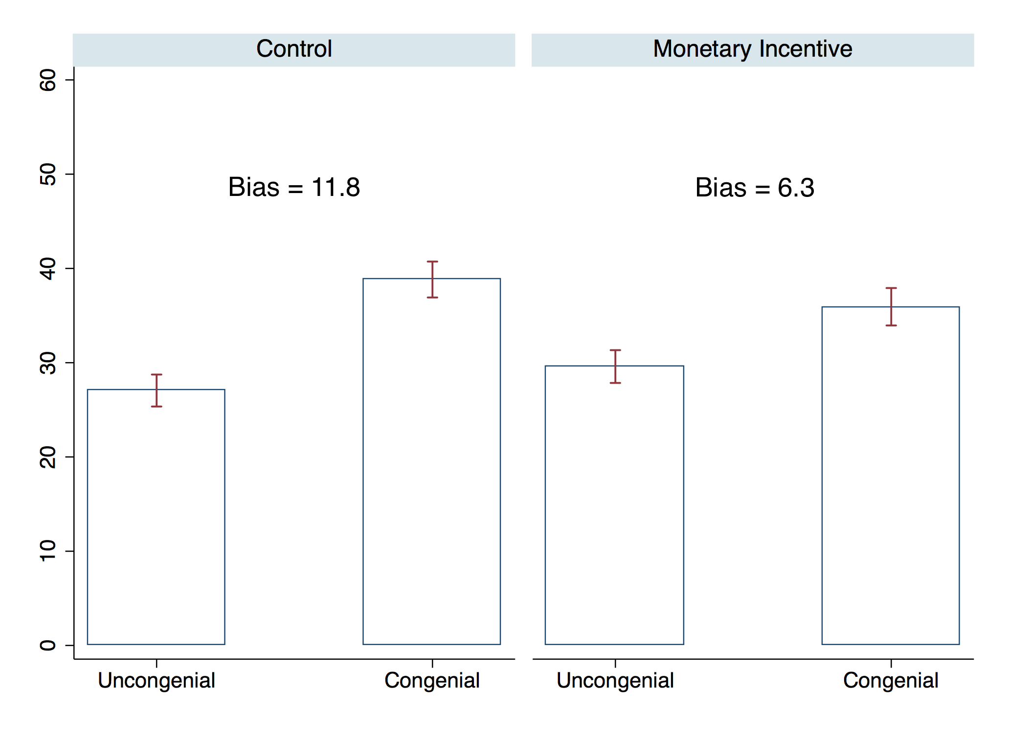

b) Study 2 only
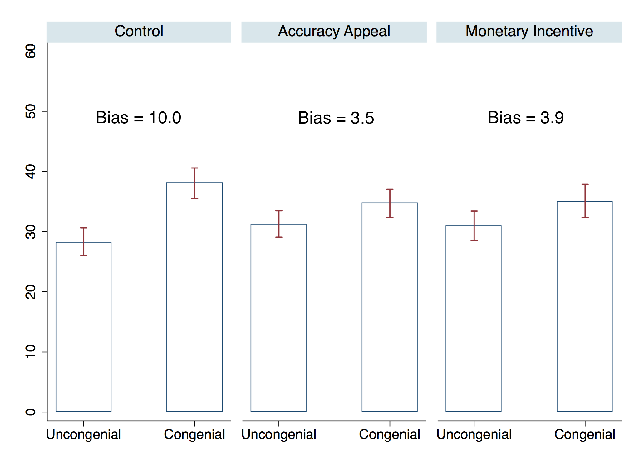

Note: Graphs plot predicted probabilities from Table 2, columns (1) and (2a), as well as 95 percent confidence intervals. Probabilities are multiplied by 100 to make them comparable to percentages reported in Table 1.

Figure 2: Treatment Effects by General Political Knowledge

a) Observed Probabilities (Lowess Smoothed)
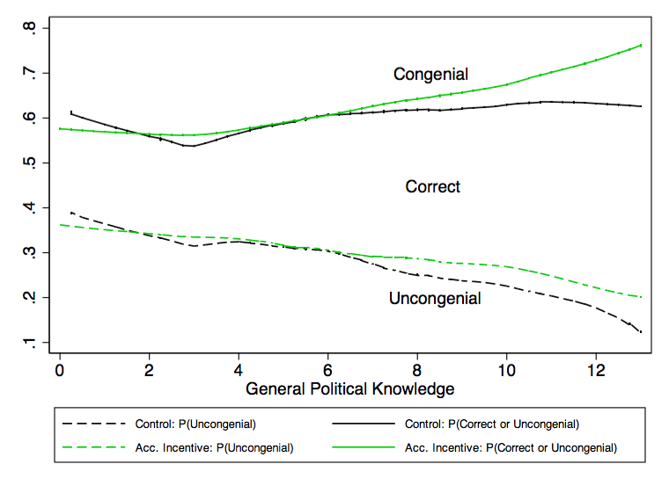
c) Observed Bias (Lowess Smoothed)
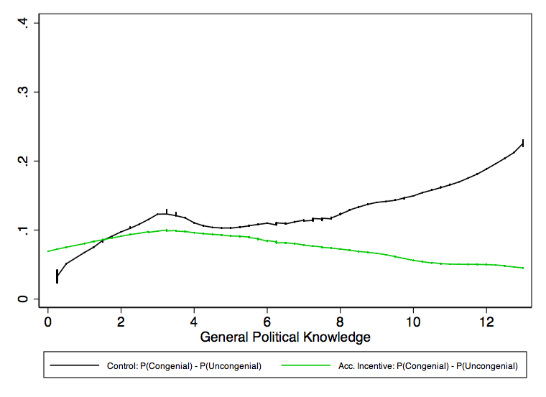
b) Predicted Probabilities (Hierarchical Multinomial Logit)
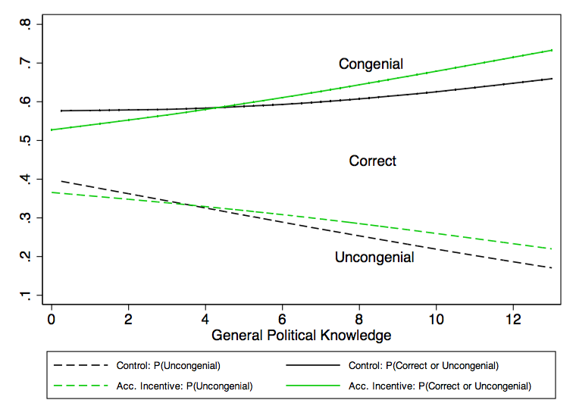
d) Predicted Level of Bias (Hierarchical Multinomial Logit)
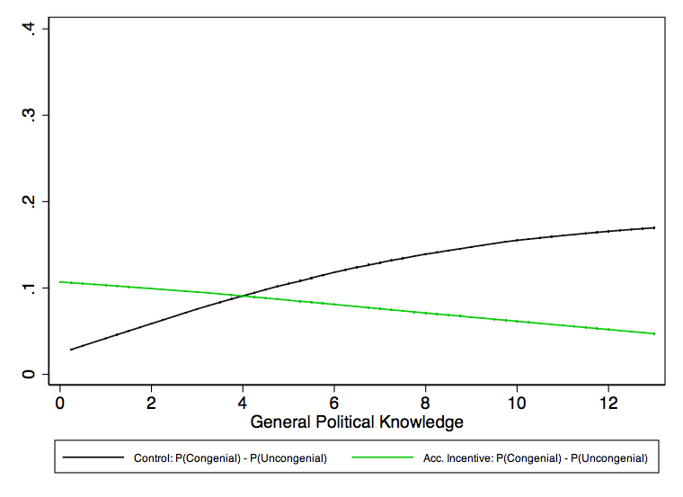

Note: In (a) and (b), dashed lines indicate the probability of an uncongenial response, and solid lines indicate the cumulative probability of uncongenial and correct responses. In (c) and (d), dark and light lines indicate level of bias in control and accuracy conditions, respectively.

While consistency goals are an important type of directional goal, other directional goals may exist.
Median screen completion times, measured in Study 2, provide a manipulation check: they were 9 seconds in the control, 30s in the monetary incentive, and 22s in the accuracy appeal condition.
This design follows Achen and Bartels (2006, 24), who suggest that the reference to President Clinton in the 1996 ANES budget deficit question “may have encouraged people… to connect their responses to their partisan predispositions.”
We define a response as complete if the respondent reached the last economic knowledge question. There is no evidence that treatment affected completion rates (see Online Appendix: Part A).
The average fraction selecting “next question” without answering was 3.2 percent in Study 1 and 1.7 percent in Study 2.
We make one correction even for trichotomized variables: Gas price responses of $100 or higher were divided by 100 on the assumption that they failed to include a decimal point.
On the estate tax question, partisan consistency leads Republicans to overstate how many people pay estate tax (following the Republican argument that it affects many people and businesses) and Democrats to understate the estate tax base (following the argument that it only affects the wealthy).
We estimate the model via maximum likelihood using the Stata library GLLAMM (Rabe-Hesketh, Skrondal, and Pickles 2004, 2005). Within GLLAMM, we use adaptive quadrature (Naylor and Smith 1982) to numerically integrate the marginal likelihood (which has no closed-form solution). We specify a weakly informative gamma prior (shape = 2 and scale = 10,000) for random effects variances, in order to avoid boundary estimates (Chung et al. 2013).
Appendix B presents a series of robustness checks to ensure that treatment effects were not caused by “cheating” (i.e, respondents consulting outside help) or by our scoring rule for “correct” answers. Dropping responses with longer screen completion times or respondents with high-speed Internet does not significantly change our estimates. Our findings are also robust to alternative scoring rules.
Study 1 did not measure presidential approval, so we cannot examine the equivalent subset there.
Table A2 shows question wording; Figure A1 plots the distribution of knowledge by partisanship.
The model pools over types of accuracy incentive because the relationship is roughly the same across conditions (χ²[4] = 6.5, p = .17).
These estimates are not directly comparable because Bullock et al. (2015) drop factual questions without partisan gaps in the control group and because they examine the difference in reported conditions between Republican and Democrats, whereas we measure partisan bias as the probability difference between congenial and uncongenial responses.

